Chapter 3
Demand, Supply, and Market Equilibrium
- Demand is a schedule or a curve showing the amount of a product that buyers are willing and able to purchase, in a particular time period, at each possible price in a series of prices.

- The law of demand states that, other things equal, the quantity of a good purchased varies inversely with its price.

- The demand curve shifts because of changes in (a) consumer tastes, (b) the number of buyers in the market, (c) consumer income, (d) the prices of substitute or complementary goods, and (e) consumer expectations.

- A change in demand is a shift of the demand curve; a change in quantity demanded is a movement from one point to another on a fixed demand curve.

- A supply schedule or curve shows that, other things equal, the quantity of a good supplied vary directly with its price.

- The supply curve shifts because of changes in (a) resource prices, (b) technology, (c) taxes or subsidies, (d) prices of other goods, (e) expectations of future prices, and (f) the number of suppliers.

- A change in supply is a shift of the supply curve; a change in quantity supplied is a movement from one point to another on a fixed supply curve.

- In competitive markets, prices adjust to the equilibrium level at which quantity demanded equals quantity supplied.

- The equilibrium price and quantity are those indicated by the intersection of the supply and demand curves for any product or resource.

- An increase in demand increases equilibrium price and quantity; a decrease in demand decreases equilibrium price and quantity.

- An increase in supply reduces equilibrium price but increases equilibrium quantity; a decrease in supply increases equilibrium price but reduces equilibrium quantity.

- Over time, equilibrium price and quantity may change in directions that seem at odds with the laws of demand and supply because the other-things-equal assumption is violated.

- Government-controlled prices in the form of ceilings and floors stifle the rationing function of prices, distort resource allocations, and cause negative side effects.

Summary of Demand, Supply & Equilibrium

1. Demand is a schedule or curve representing the willingness of buyers in a specific period to purchase a particular product at each of various prices. The law of demand implies that consumers will buy more of a product at a low price than at a high price. So, other things equal, the relationship between price and quantity demanded is negative or inverse and is graphed as a downsloping curve.

2. Market demand curves are found by adding horizontally the demand curves of the many individual consumers in the market.

3. Changes in one or more of the determinants of demand (consumer tastes, the number of buyers in the market, the money incomes of consumers, the prices of related goods, and consumer expectations) shift the market demand curve. A shift to the right is an increase in demand; a shift to the left is a decrease in demand. A change in demand is different from a change in the quantity demanded, the latter being a movement from one point to another point on a fixed demand curve because of a change in the product’s price.

4. Supply is a schedule or curve showing the amounts of a product that producers are willing to offer in the market at each possible price during a specific period. The law of supply states that, other things equal, producers will offer more of a product at a high price than at a low price. Thus, the relationship between price and quantity supplied is positive or direct, and supply is graphed as an upsloping curve.

5. The market supply curve is the horizontal summation of the supply curves of the individual producers of the product.

6. Changes in one or more of the determinants of supply (resource prices, production techniques, taxes or subsidies, the prices of other goods, producer expectations, or the number of sellers in the market) shift the supply curve of a product. A shift to the right is an increase in supply; a shift to the left is a decrease in supply. In contrast, a change in the price of the product being considered causes a change in the quantity supplied, which is shown as a movement from one point to another point on a fixed supply curve.

7. The equilibrium price and quantity are established at the intersection of the supply and demand curves. The interaction of market demand and market supply adjusts the price to the point at which the quantities demanded and supplied are equal. This is the equilibrium price. The corresponding quantity is the equilibrium quantity.

8. The ability of market forces to synchronize selling and buying decisions to eliminate potential surpluses and shortages is known as the rationing function of prices. The equilibrium quantity in competitive markets reflects both productive efficiency (least-cost production) and allocative efficiency (the right amount of the product relative to other products).

9. A change in either demand or supply changes the equilibrium price and quantity. Increases in demand raise both equilibrium price and equilibrium quantity; decreases in demand lower both equilibrium price and equilibrium quantity. Increases in supply lower equilibrium price and raise equilibrium quantity; decreases in supply raise equilibrium price and lower equilibrium quantity.

10. Simultaneous changes in demand and supply affect equilibrium price and quantity in various ways, depending on their direction and relative magnitudes (see Table 3.3).

11. A price ceiling is a maximum price set by government and is designed to help consumers. Effective price ceilings produce persistent product shortages, and if an equitable distribution of the product is sought, government must ration the product to consumers.

12. A price floor is a minimum price set by government and is designed to aid producers. Effective price floors lead to persistent product surpluses; the government must either purchase the product or eliminate the surplus by imposing restrictions on production or increasing private demand.

13. Legally fixed prices stifle the rationing function of prices and distort the allocation of resources.

MCQ’s on Demand, Supply, and Market Equilibrium
- When an economist says that the demand for a product has increased, this means that:
- Quantity demanded is greater at each possible price
- Firms make less of the product available for sale
- Consumers respond to a lower price by buying more
- The demand curve becomes steeper

- When movie ticket prices increase, families tend to spend less time watching movies and more time at home watching videos instead. This best reflects:
- Diminishing marginal utility
- The income effect
- The rationing function of markets
- The substitution effect

- If consumer incomes increase, the demand for product Y:
- Will necessarily remain unchanged
- Will shift to the right if y is a complementary good
- Will shift to the right if y is a normal good
- Will shift to the right if y is an inferior good

- When drawing demand and supply curves, economists are assuming that the primary influence on production and purchasing decisions is:
- Price
- The cost of production
- The overall state of the economy
- Consumer incomes

- Refer to the following diagrams, Which one of the diagram best illustrates the effect of an increase in crude oil prices on the market for gasoline:
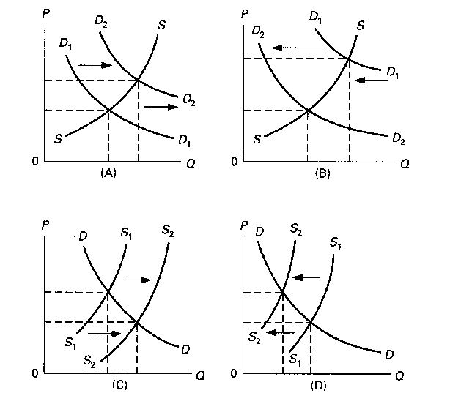
- A
- B
- C
- D

- A decrease in the price of a product will increase the amount of it demanded because:
- Supply curves are upsloping
- The lower price will decrease real incomes
- The lower price induces consumers to use this product instead of similar products
- Firms produce more at lower prices
- "Because of unusually good growing conditions, the supply of strawberries has substantially increased." This statement indicates that:
- The demand for strawberries will necessarily rise
- The equilibrium quantity of strawberries will fall
- The amount of strawberries that will be available at various prices has increased
- The price of strawberries will rise

- Goods X and Y are complements while goods X and Z are substitutes. If the supply of good X increases:
  - The demand for both Y and Z will increase
  - The demand for Y will increase while the demand for Z will decrease
  - The demand for Y will decrease while the demand for Z will increase
  - The demand for both Y and Z will decrease

- The following data show the supply and demand schedule for a competitively produced good Refer to this data. At the equilibrium price, the quantity exchanged in this market will be:
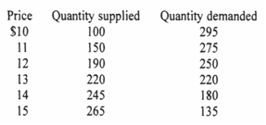
- 190
- 220
- 245
- 250

- An improvement in production technology for a specific good will cause a(n):
  - Increase in demand and an increase in price
  - Increase in demand and a drop in price
  - Drop in price and increase in quantity demanded
  - Increase in supply and an increase in price

Questions on Demand, Supply, and Market Equilibrium
- What effect will each of the following have on the demand for small automobiles such as the Mini Cooper and Smart car?
- Small automobiles become more fashionable.
Demand Increase
- The price of large automobiles rises (with the price of small autos remaining the same).
Demand of small auto car will rise & Demand of large auto car will below
- Income declines and small autos are an inferior good.
Demand will increase
- Consumers anticipate that the price of small autos will greatly come down in the near future.
Demand will decrease
- The price of gasoline substantially drops.

- What effect will each of the following have on the supply of auto tires?
  - A technological advance in the methods of producing tires.
Supply will increase
  - A decline in the number of firms in the tire industry.
Supply will decrease
  - An increase in the prices of rubber used in the production of tires.
Supply will Decrease
  - The expectation that the equilibrium price of auto tires will be lower in the future than currently.
Supply will increase
  - A decline in the price of the large tires used for semi-trucks and earth-hauling rigs (with no change in the price of auto tires).
Supply will increase
  - The levying of a per-unit tax on each auto tire sold.
Supply will decrease
  - The granting of a 50-cent-per-unit subsidy for each auto tire produced.
Supply will Increase

- Suppose the total demand for wheat and the total supply of wheat per month in the Kansas City grain market are as shown in the accompanying table.
Thousands of bushels demand | Price per Bushels | Thousands of bushels Supplied | Surplus (+) OR  Shortage (-)
85 | $3.40 | 72 | ________
80 | 3.70 | 73 | ________
75 | 4.00 | 75 | ________
70 | 4.30 | 77 | ________
65 | 4.60 | 79 | ________
60 | 4.90 | 81 | ________

- What is the equilibrium price? What is the equilibrium quantity? Fill in the surplus-shortage column and use it to explain why your answers are correct.
- Graph the demand for wheat and the supply of wheat. Be sure to label the axes of your graph correctly. Label equilibrium price P and equilibrium quantity Q
- Why will $3.40 not be the equilibrium price in this market? Why not $4.90? “Surpluses drive prices up; shortages drive them down.” Do you agree?
- How will each of the following changes in demand and/or supply affect equilibrium price and equilibrium quantity in a competitive market; that is, do price and quantity rise, fall, or remain unchanged, or are the answers indeterminate because they depend on the magnitudes of the shifts? Use supply and demand diagrams to verify your answers.
- Supply decreases and demand is constant.
- Demand decreases and supply is constant.
- Supply increases and demand is constant.
- Demand increases and supply increases.
- Demand increases and supply is constant.
- Supply increases and demand decreases.
- Demand increases and supply decreases.
- Demand decreases and supply decreases.

- Refer to the table in question 3. Suppose that the government establishes a price ceiling of $3.70 for wheat. What might prompt the government to establish this price ceiling? Explain carefully the main effects. Demonstrate your answer graphically. Next, suppose that the government establishes a price floor of $4.60 for wheat. What will be the main effects of this price floor? Demonstrate your answer graphically.

