Final Project

INTRODUCTION TO MARKETING

Presented to: Basharatullah Malik
Section “O”
Presented by:

NAME Reg No Sr No
Ghulam Hassan L1F10BBAM0277 09
Yasir abbas L1F10BBAM2276 39
Abdullah Saeed L1F10BBAM0301 10

Dated: 08-June 2011
Final Project
Market Concepts & Analysis
New product development is the term used to describe the complete process of bringing a new product to market.
A product is a set of benefits offered for exchange and can be tangible (that is, something physical you can touch) or intangible (like a service, experience, or belief). A product is also the end result of the manufacturing process, to be offered to the marketplace to satisfy a need or want.
There are two parallel paths involved in the new product development process:
- First involves the idea generation, product design and detail engineering
- The other involves market research and marketing analysis.

- What is the Product that we are launching?
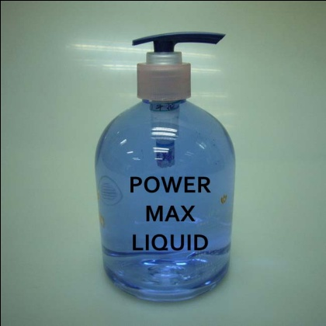
We are launching a different product in market that you had never seen in your life.
We are introducing first time in Pakistan,
Such liquid that quit change your life style.
The Power Max Liquid we gave guarantee

That after use of this Liquid, you have not want to polish your car.
- Consumer behavior:
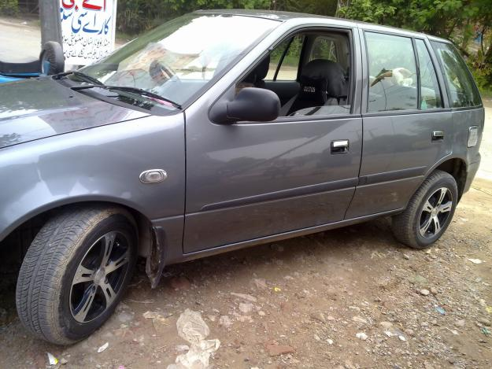
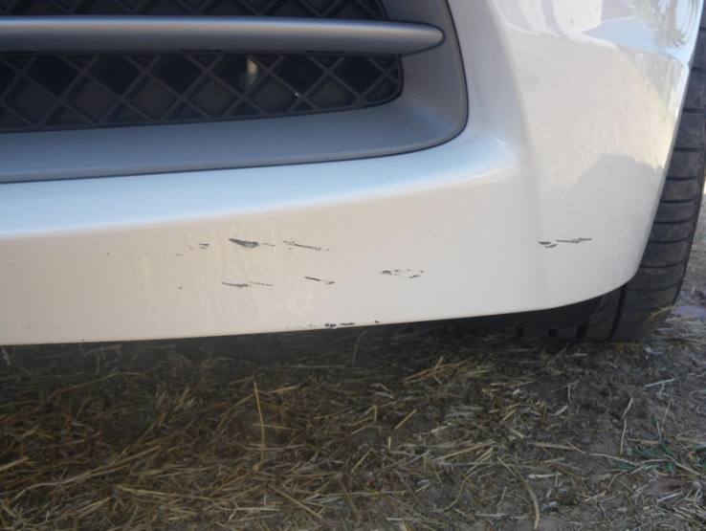
Consumer behavior is the study of when, why, how, and where people do or do not buy a product. Cars are basically a higher amount assets and every consumer wants to keep their car clean, new, shine and gorgeous look. Mostly service stations & consumer wash their cars with detergents, Shampoos and other material that leave a negative effect on cars shine and gradually car become dull, the paint of car lose their shine and what the result?

Car become with scratches and dull because detergents are in the form of grainy and this become the cause of scratches. And also these types of material are consist upon phosphate that is a strike of paint these type of liquids basically had not making especially for the cars cleaning. So, it gave only adhok cleaning and cars lose their reputations

The Power Max Liquid had been made after keeping in touch your difficulties & problem that you faced after cleaning your cars. Consumer wants to see a shine car but when we survey the consumer behavior, 50% of them want to wash their car from service stations. From which 90% service stations use cheep detergents and polishes. And 50% consumers want to wash it on self. From which 60% consumer use shampoos as washing and 37% use detergents (sarf) and only 3% use good quality liquids.
So what is reason that 97% of population have no idea about using such liquids that become helpful for keep their cars shine and new.
1st reason is that these types of liquids are so expensive while their prices are starting from 850 to 1500 per 200ml bottle. When we survey the service stations then we have come to know that they charged 150 to 250 for wash & polish a car. So it’s mean they cannot get profit with using high quality liquids
2nd reason is that these types of liquids are not popular in low and middle class level so they insist for cheep detergents. And use hair shampoos, liquid dish washers, liquid hand wash and some of them use detergents (sarf).
3rd reason is that these types of liquids are mostly not available at nearly stores so consumers do not pay any attention on these types of liquids.

- The process of Developing Product

- Idea Generation:
Ideas for new products can be obtained from basic research using a SWOT analysis (Strengths, Weaknesses, and Opportunities & Threats), Market and consumer trends, company's R & D department, competitors, focus groups, employees, salespeople, corporate spies and trade shows
Lots of ideas are being generated about the new product. Out of these ideas, many ideas are being implemented. The ideas use to generate in many forms and their generating places are also various. Many reasons are responsible for generation of an idea.
When we survey the consumer behavior, 50% of them want to wash their cars from service stations. From which 90% service stations use cheep detergents and polishes. And rest 50% consumers want to wash it on self. From which 60% consumer use shampoos as washing and 37 % consumer use detergents (sarf) and only 3% use good quality liquids.
So there are so many reason that 97% of population has no idea about using such liquids that become helpful for keep their cars shine and new.
On these reasons we generate an idea to launch such type of liquid which will helpful for all type of consumer. And from all class belongs can easily purchase it & use it.

- Idea Screening
The object is to eliminate unsound concepts prior to devoting resources to them. The screeners should ask several questions:
- Will the customer in the target market benefit from the product?
Obviously, every consumer wants to see their car neat, shine and new. So if he find such product that is available in his range and he got it easily from anywhere and he have no necessity for any extra charges like polish charges,,, so obviously consumers will get benefits from this product in target market.
- What is the size and growth forecasts of the market segment/target market?
Market segment as geographical will the urban areas of Lahore and the target market will be Montgomery road Lahore.
- What is the current or expected competitive pressure for the product idea?
Basically most of the people have no idea about these types of products so we have no any expected competitive pressure for the product idea but we have set our minds that competitors may be taken such decision that fall our marketing reputation like they
may be decrease their product price or start any scheme for promote their product more than more. But we are ready for these challenges.
- What are the industry sales and market trends the product idea is based on?
97% of population has no idea about using such liquids that become helpful for keep their cars shine, clean and new. Because market trends about this type of products are you can get idea about industry sales that only 3% population (based on our survey) knows about this type of liquids.
- Is it technically feasible to manufacture the product?
Yes! This is technically feasible to manufacture the product because the process of manufacture this product is so easy. And cost on its manufacturing is not more than Rs 150/=
- Will the product be profitable when manufactured and delivered to the customer at the target price?

- Product Development and Testing
Develop the marketing and engineering details
Product development develops concept into a physical product in order to ensure that the product idea can be turned in to a workable market offering. In this, we had know that:
- Who is the target market and who is the decision maker in the purchasing process?
A target market is a group of customers that the business has decided to aim its marketing efforts and ultimately its merchandise. A well defined target market is the first element to a marketing strategy. For our product, target market will be Montgomery road, and the focus on this aim that this will be available at all service stations, Patrol pumps, and small car accessory markets. Decision maker in purchases process will be owner of car, head of family, drivers and service station owners.
- What benefits will the product provide?
The Product had been made after keeping in touch your difficulties & problem that you faced after cleaning your cars. Consumer wants to see a shine car, with low cost and without polish after washing. & these benefits will the product provide.
- How will consumers react to the product?
- What will it cost to produce it?
The cost of produce this product is Rs 165/= (large) & Rs 95 (small)
Testing the Concept by asking a sample of prospective customers what they think of the idea. Usually via Choice Modeling
We take a survey on this test and customers chose mostly the idea of such product that we are launch. Because 95% customers want to such liquid that become helpful for customers to keep their cars shine.

- Business Analysis
Business analysis involves a review of the sales, costs, and profit projections to assess fit with company objectives. If results are positive, project moves to the product development phase. In which we:
- Estimate likely selling price based upon competition and customer feedback
The selling price will close to Rs 210/= to 225/= because mostly consumers use the washing detergents or shampoos prices are start from Rs 150/= to 250/=
- Estimate sales volume based upon size of market and such tools as the Fourth Woodblock equation
Sales volume will be start from 1000 bottles (large) and 500 bottles (small) and in first stock, a sponge will be gave with every 250ml bottle free of cost
- Estimate profitability and break-even point
Breakeven point is at sale of 750 bottles (large) & 330 bottles (small) & Profitability point start after sale of 750 bottles (large) & 330 bottles (small)

- Beta Testing and Market Testing
In test marketing, Product and marketing program are introduced in a more realistic market setting. This is not needed for all products. This can be expensive and time consuming, but better than making a major marketing mistake. This involves:
- Produce a physical prototype or mock-up
- Test the product (and its packaging) in typical usage situations
- Conduct focus group customer interviews or introduce at trade show
- Make adjustments where necessary
- Produce an initial run of the product and sell it in a test market area to determine customer acceptance
- Commercialization (often considered post-NPD)
Commercialization must decide on timing that when to introduce the product. Must decide on where to introduce the product (e.g single location, state, region, nationally, internationally) must develop a market rollout plan. In Commercialization:
- Launch the product
- Produce and place advertisements and other promotions
- Fill the distribution pipeline with product
- Critical path analysis is most useful at this stage

- New Product Pricing
- Impact of new product on the entire product portfolio
- Value Analysis (internal & external)
- Competition and alternative competitive technologies
- Differing value segments (price, value, and need)

- Product Costs (fixed & variable)
Total variable cost is Rs 95/= per unit (on large bottle) and Rs 48/= per unit (small) and Rs 91,000/= are fixed cost per month
- Forecast of unit volumes, revenue, and profit
We will manufacture 1000 bottles (large) and 500 bottles (small) and the total cost of these manufactured items will 212,500 and we generate 287,500 and profit will be 75,000

These steps may be iterated as needed. Some steps may be eliminated. To reduce the time that the New Product Development process takes, many companies are completing several steps at the same time (referred to as concurrent engineering or time to market). Most industry leaders see new product development as a proactive process where resources are allocated to identify market changes and seize upon new product opportunities before they occur (in contrast to a reactive strategy in which nothing is done until problems occur or the competitor introduces an innovation). Many industry leaders see new product development as an ongoing process (referred to as continuous development) in which the entire organization is always looking for opportunities.

- Geographical area of target market:
Two important factors to consider when selecting a target market segment are the attractiveness of the segment and the fit between the segment and the firm's objectives, resources, and capabilities.
Attractiveness of a Market Segment
The following are some examples of aspects that should be considered when evaluating the attractiveness of a market segment:
- Size of the segment (number of customers and/or number of units)
There are 10 million people live in Lahore and million people have cars
- Growth rate of the segment
Growth rate will be 5% of total sale per month
- Competition in the segment
Obviously, there will be a competition in target market and all segments of product
- Brand loyalty of existing customers in the segment
- Attainable market share given promotional budget and competitors' expenditures
- Required market share to break even
- Sales potential for the firm in the segment
- Expected profit margins in the segment

Market research and analysis is instrumental in obtaining this information. For example, buyer intentions, sales force estimates, test marketing, and statistical demand analysis are useful for determining sales potential. The impact of applicable micro environmental and macro environmental variables on the market segment should be considered.

Note that larger segments are not necessarily the most profitable to target since they likely will have more competition. It may be more profitable to serve one or more smaller segments that have little competition. On the other hand, if the firm can develop a competitive advantage, for example, via patent protection, it may find it profitable to pursue a larger market segment.
- Suitability of Market Segments to the Firm
Market segments also should be evaluated according to how they fit the firm's objectives, resources, and capabilities. Some aspects of fit include:
- Whether the firm can offer superior value to the customers in the segment
- The impact of serving the segment on the firm's image
- Access to distribution channels required to serve the segment
- The firm's resources vs. capital investment required to serve the segment
The better the firm's fit to a market segment and the more attractive the market segment, the greater the profit potential to the firm.

- Target Market Strategies
There are several different target market strategies that may be followed. Targeting strategies usually can be categorized as one of the following:
- Single-segment strategy
This is also known as a concentrated strategy. One market segment (not the entire market) is served with one marketing mix. A single segment approach often is the strategy of choice for smaller companies with limited resources.
- Selective specialization
This is a multiple-segment strategy, also known as a differentiated strategy. Different marketing mixes are offered to different segments. The product itself may or may not be different. In many cases only the promotional message or distribution channels vary.
- Product specialization
The firm specializes in a particular product and tailors it to different market segments.
- Market specialization
The firm specializes in serving a particular market segment and offers that segment an array of different products.
- Full market coverage
The firm attempts to serve the entire market. This coverage can be achieved by means of either a mass market strategy in which a single undifferentiated marketing mix is offered to the entire market, or by a differentiated strategy in which a separate marketing mix is offered to each segment.

A firm that is seeking to enter a market and grow should first target the most attractive segment that matches its capabilities. Once it gains a foothold, it can expand by pursuing a product specialization strategy, tailoring the product for different segments, or by pursuing a market specialization strategy and offering new products to its existing market segment.

- Segmentation & Identification of Target Market:
Market segmentation is the identification of portions of the market that are different from one another. Segmentation allows the firm to better satisfy the needs of its potential customers.
- The Need for Market Segmentation:
The marketing concept observed for understanding customers and satisfying their needs better than the competition. But different customers have different needs, and it rarely is possible to satisfy all customers by treating them alike.

- Bases for Segmentation in Consumer Markets

Consumer markets can be segmented on the following customer characteristics.

- Geographic
- Demographic
- Psychographic
- Behavioralistic

- Geographic Segmentation
The following are some examples of geographic variables often used in segmentation.
- Region:
By continent, country, state, or even neighborhoods like our product will be selling in Pakistan region now.
- Size of metropolitan area:
Segmented according to size of population like our product will be selling in Lahore
- Population density:
Often classified as urban, suburban, or rural like our product will be selling in urban areas of Lahore
- Climate:
According to weather patterns common to certain geographic regions. Like our product will be selling in the areas or Lahore

- Demographic Segmentation
Some demographic segmentation variables include:

- Age
- Gender
- Family size
- Family lifecycle
- Generation: baby-boomers, Generation X, etc.
- Income
- Occupation
- Education
- Ethnicity
- Nationality
- Religion
- Social class
Many of these variables have standard categories for their values. For example, family lifecycle often is expressed as bachelor, married with no children (DINKS: Double Income, No Kids), full-nest, empty-nest, or solitary survivor. Some of these categories have several stages, for example, full-nest I, II, or III depending on the age of the children.

- Psychographic Segmentation
Psychographic segmentation groups customers according to their lifestyle. Activities, interests, and opinions (AIO) surveys are one tool for measuring lifestyle. Some psychographic variables include:

- Activities
- Interests
- Opinions
- Attitudes
- Values
- Behavioralistic Segmentation
Behavioral segmentation is based on actual customer behavior toward products. Some Behavioralistic variables include:
- Benefits sought
- Usage rate
- Brand loyalty
- User status: potential, first-time, regular, etc.
- Readiness to buy
- Occasions: holidays and events that stimulate purchases
Behavioral segmentation has the advantage of using variables that are closely related to the product itself. It is a fairly direct starting point for market segmentation.
- Marketing Mix:
Marketing decisions generally fall into the following four controllable categories:
- Product
- Price
- Place (distribution)
- Promotion

These four P's are the parameters that the marketing manager can control, subject to the internal and external constraints of the marketing environment. The goal is to make decisions that center the four P's on the customers in the target market in order to create perceived value and generate a positive response.
- Product Decisions
The term "product" refers to tangible, physical products as well as services. Here are some examples of the product decisions to be made:
    - Brand name
    - Functionality
    - Styling
    - Quality
    - Safety
    - Packaging
    - Repairs and Support
    - Warranty
    - Accessories and services
We launch the power max liquid (Brand Name) with different functionalities like you can use this liquid for washing your cars, washing your bikes, and other heavy vehicles. Our product is available in different style like you can get a car wash sponge free of cost (at first stock only). Our product has a different and best quality for use. It is 100% free from any dangers chemical and the
work quality of this product is 100%. This will give u a Disembarrassment from all stink detergents and chemicals that destroy your hands and eyes. The packing of our product will be in two shapes 250 ml and 125 ml bottles. Our product will be seal pack and any complaint will be accepted and we will replace it as a new bottle. We will gave money back guarantee that if our product will not give u a shine car or you feel a need of polish your car after use it.
- Price Decisions
Some examples of pricing decisions to be made include:
- Pricing strategy (skim, penetration, etc)
- Suggested retail price
- Volume discounts and wholesale pricing
- Cash and early payment discounts
- Seasonal pricing
- Bundling
- Price flexibility
- Price discrimination
Price of The power max liquid will be Rs 250/= (250ml) and Rs 150/= (125ml) in Retail & Price of The power max liquid will be Rs 225/= (250ml) and Rs 125/= (125ml) in wholesale. If a wholesaler purchase 1000 bottles (250ml) (cash) than 5% discount will be granted. And if a wholesaler purchase 2500 bottles (250ml) then 50 bottle (125ml) will be gave free of cost. Price will remain same on all seasons. A bundle will be consisting upon 50 bottles.
- Place (Distribution) Decisions
Distribution is about getting the products to the customer. Some examples of distribution decisions include:
- Distribution channels
- Market coverage (inclusive, selective, or exclusive distribution)
- Specific channel members
- Inventory management
- Warehousing
- Distribution centers
- Order processing
- Transportation
- Reverse logistics
- Promotion Decisions
In the context of the marketing mix, promotion represents the various aspects of marketing communication, that is, the communication of information about the product with the goal of generating a positive customer response. Marketing communication decisions include:
- Promotional strategy (push, pull, etc.)
- Advertising
- Personal selling & sales force
- Sales promotions
- Public relations & publicity
- Marketing communications budget
- BCG Matrix:
Placing products in the BCG matrix results in 4 categories in a portfolio of a company:

- BCG STARS (high growth, high market share)
Stars are defined by having high market share in a growing market. Stars are the leaders in the business but still need a lot of support for promotion a placement. If market share is kept, Stars are likely to grow into cash cows.

- BCG QUESTION MARKS (high growth, low market share)
These products are in growing markets but have low market share. Question marks are essentially new products where buyers have yet to discover them. The marketing strategy is to get markets to adopt these products. Question marks have high demands and low returns due to low market share. These products need to increase their market share quickly or they become dogs. The best way to handle Question marks is to either invest heavily in them to gain market share or to sell them.

- BCG CASH COWS (low growth, high market share)
Cash cows are in a position of high market share in a mature market. If competitive advantage has been achieved, cash cows have high profit margins and generate a lot of cash flow. Because of the low growth, promotion and placement investments are low. Investments into supporting infrastructure can improve efficiency and increase cash flow more. Cash cows are the products that businesses strive for.

- BCG DOGS (low growth, low market share)
Dogs are in low growth markets and have low market share. Dogs should be avoided and minimized. Expensive turn around plans usually does not help.
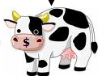
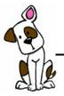
Market Growth

High

Low

High Low
Market Share

In BCG Matrix our product is now on question mark because our product is in growing process.
- The Product Life Cycle
A product's life cycle (PLC) can be divided into several stages characterized by the revenue generated by the product. If a curve is drawn showing product revenue over time, it may take one of many different shapes, an example of which is shown below:
Decline
Maturity
Growth
Introduction
Development

SALES

TIME

The life cycle concept may apply to a brand or to a category of product. Its duration may be as short as a few months for a fad item or a century or more for product categories such as the gasoline-powered automobile.
- Product development
Product development is the incubation stage of the product life cycle; there are no sales and the firm prepares to introduce the product. As the product progresses through its life cycle, changes in the marketing mix usually are required in order to adjust to the evolving challenges and opportunities.
- Introduction Stage
When the product is introduced, sales will be low until customers become aware of the product and its benefits. Some firms may announce their product before it is introduced, but such announcements also alert competitors and remove the element of surprise. Advertising costs typically are high during this stage in order to rapidly increase customer awareness of the product and to target the early adopters. During the introductory stage the firm is likely to incur additional costs associated with the initial distribution of the product. These higher costs coupled with a low sales volume usually make the introduction stage a period of negative profits.
During the introduction stage, the primary goal is to establish a market and build primary demand for the product class. The following are some of the marketing mix implications of the introduction stage:
Product - > one or few products, relatively undifferentiated
Price - > Generally high, assuming a skim pricing strategy for a high profit margin as the early adopters buy the product and the firm seeks to recoup development costs quickly. In some cases a penetration pricing strategy is used and introductory prices are set low to gain market share rapidly.
Distribution - > Distribution is selective and scattered as the firm commences implementation of the distribution plan.
Promotion - > Promotion is aimed at building brand awareness. Samples or trial incentives may be directed toward early adopters. The introductory promotion also is intended to convince potential resellers to carry the product.

- Growth Stage

The growth stage is a period of rapid revenue growth. Sales increase as more customers become aware of the product and its benefits and additional market segments are targeted. Once the product has been proven a success and customers begin asking for it, sales will increase further as more retailers become interested in carrying it. The marketing team may expand the distribution at this point. When competitors enter the market, often during the later part of the growth stage, there may be price competition and or increased promotional costs in order to convince consumers that the firm's product is better than that of the competition.
During the growth stage, the goal is to gain consumer preference and increase sales. The marketing mix may be modified as follows:
Product - > New product features and packaging options; improvement of product quality.
Price - > Maintained at a high level if demand is high, or reduced to capture additional customers.
Distribution - > Distribution becomes more intensive. Trade discounts are minimal if resellers show a strong interest in the product.
Promotion - > Increased advertising to build brand preference.

- Maturity Stage
The maturity stage is the most profitable. While sales continue to increase into this stage, they do so at a slower pace. Because brand awareness is strong, advertising expenditures will be reduced. Competition may result in decreased market share and/or prices. The competing products may be very similar at this point, increasing the difficulty of differentiating the product. The firm places effort into encouraging competitors' customers to switch, increasing usage per customer, and converting non-users into customers. Sales promotions may be offered to encourage retailers to give the product more shelf space over competing products.
During the maturity stage, the primary goal is to maintain market share and extend the product life cycle. Marketing mix decisions may include:
Product - > Modifications are made and features are added in order to differentiate the product from competing products that may have been introduced.
Price - > Possible price reductions in response to competition while avoiding a price war.
Distribution - > New distribution channels and incentives to resellers in order to avoid losing shelf space.
Promotion - > Emphasis on differentiation and building of brand loyalty. Incentives to get competitors' customers to switch.

- Decline Stage
Eventually sales begin to decline as the market becomes saturated, the product becomes technologically obsolete, or customer tastes change. If the product has developed brand loyalty, the profitability may be maintained longer. Unit costs may increase with the declining production volumes and eventually no more profit can be made.
During the decline phase, the firm generally has three options:
- Maintain the product in hopes that competitors will exit. Reduce costs and find new uses for the product.
- Harvest it, reducing marketing support and coasting along until no more profit can be made.
- Discontinue the product when no more profit can be made or there is a successor product.

The marketing mix may be modified as follows:
Product - > The number of products in the product line may be reduced. Rejuvenate surviving products to make them look new again.
Price - > Prices may be lowered to liquidate inventory of discontinued products. Prices may be maintained for continued products serving a niche market.
Distribution - > Distribution becomes more selective. Channels that no longer are profitable are phased out.
Promotion - > Expenditures are lower and aimed at reinforcing the brand image for continued products.

- Profitability Analysis:
To analyze the profitability of a firm we need to analyze the revenues and the costs separately.
Profit = Revenue – cost

Estimated and Actual costs:
Manufacturing:
Direct material | 69,000
Direct labour | 37,000
Variable overhead | 13,000
Fixed overhead | 91,000
Total manufacturing cost | 210,000
Non-Manufacturing:
Variable selling | 25,000
Fixed selling & admin | 15,000
Total manufacturing cost | 40,000

Estimated and Actual Production:
Estimated and Actual Production = 1000 units of 250ml and 500 units of 125ml
Sales = 900 units of 250ml and 400 units of 125ml
Price Rs 165/= 250ml & Rs 95/= 125ml per unit
Beginning finished goods 0
Sales | 252,500
Cost of goods sold | 184,500
Gross profit | 68,000
Less expenses | 44,000
Operating Income | 44,000

