New Business
Analysis

ghmmhj

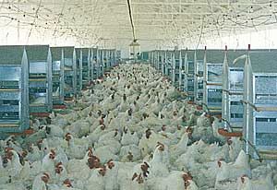
Final Project Report

Ghulam Hassan
L1F10BBAM0277 (18)
Jameel Ahmed
L1F10BBAM2276 (19)
Muzzamil Hussain
L1F10BBAM0301

Table of Content

Introduction
Current Industry Structure
Marketing
Manpower Requirements
Farm Equipment
Land & Building
Project Cost
Financial Analysis

Poultry is one the most important sector of agriculture industry in Pakistan by providing employment to 1.5 million people. According to Industry sources there is capacity of 5,000 Environmental Control Houses in Pakistan and currently 2,500 houses are working, out of which 75% (1,875) are in Punjab and remaining 25% (625) are in other provinces.
An Introduction
Control shed

Broiler meat is the cheapest source of animal protein available in Pakistan. The time required for raising broiler birds is lesser than that for big animals. The day old chicks (DOCs) are raised on high protein feed for a period of six weeks. In controlled environment the temperature, feed and drinking system is operated automatically and monitored by the trained staff.
This business can be started both in rural and semi-urban areas in sheds. These sheds have all the required facilities for the broiler farm.
The broiler birds are sold to traders and the whole sellers markets in the urban areas. Sometimes birds can also be sold directly to the shopkeepers in the urban markets.
According to the Agriculture Statistics of Pakistan the per capita consumption of poultry meat is increasing at a rate of 4% per annum.
An Introduction
Control shed

A broiler farm with a population of 35,000 birds needs a capital investment of about Rs 19.2 Million for construction, purchasing machinery & equipment.
In addition to this, a sum of Rs 5.7 Million is required as working capital, which will be used for purchasing day old chicks and raw material (feed & vaccines) etc.
The Total project cost is estimated Rs 24.9 Million.
This is a profitable business enterprise due to continuous increasing demand of the white meat in the market and export prospects especially in Muslim countries.
The generation line of broiler comes from pure line (Strains) that make the Great Grand Parents (GGP), which are imported. These great grandparents produce grandparents which are available in Pakistan. These grandparents produce parent stocks (Breeders) a parent stock end up in producing the final product which is broiler.
CURRENT INDUSTRY STRUCTURE
Presently, poultry industry contributes a large segment to the national economy with an investment of more than 70 billion of rupees and has become the second largest industry after textile in Pakistan.
Pakistan’s poultry industry is importing Grandparents (GP) chicks annually from Australia, Holland, Germany. This GP is producing Breeders that produce final products. The farmers get day old broiler from hatcheries. OR in some cases, purchase their hatching eggs from breeder farms.
Poultry feed mills are the major player in the poultry industry, which produce a specific formula feed mix. Poultry feed consists of rich protein elements like grains, gluten, blood meal, fishmeal and soya bean meal. The major component of cost of production of chicken meat accounts for feed cost.
Row Material
CURRENT INDUSTRY STRUCTURE
The poultry meat production has shown a growing trend over the past few years after a dip in 1997 due to the ban imposed on wedding dinners. The meat production trend of chicken meat, beef and mutton from the year 2006 to 2009 is presented below.
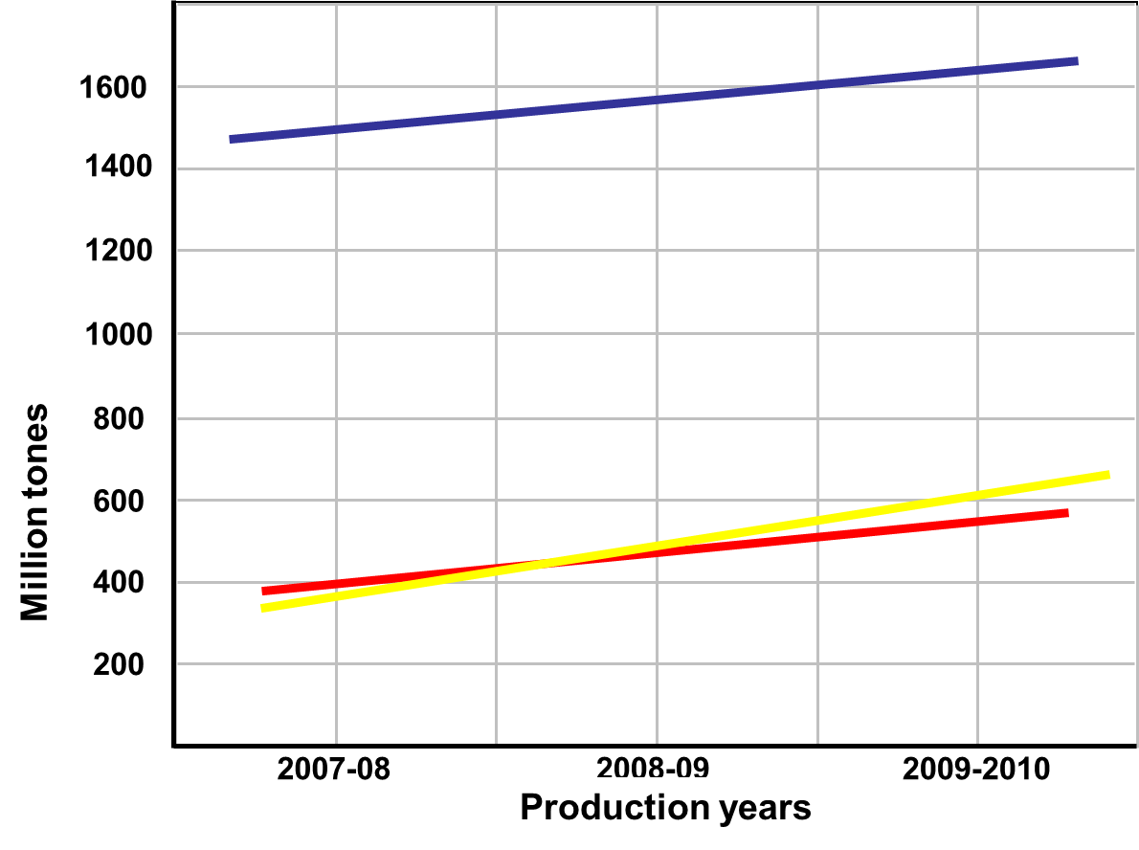
Yellow line is represent chicken, Red line is Meat and Blue line is Beef.
The marketing of chickens follows the traditional channels of distribution. Generally, broilers are distributed in the market through middlemen (Arti) and Wholesalers In some cases, the middleman provides Day Old Chicks and other farm inputs (feed, etc.) to the broiler farmers and then agrees to buy back the mature birds from them.
Marketing of Poultry farm
Birds are transported to the urban market and are sold to retailers or market-street poultry shops. Birds are sold on live-weight basis. The time spent in getting broilers from the farm to the retail shop is brief. Collection and handling of birds has improved with the use of loader vehicles.
OUR BUSINESS LOCATION

Our Business locate is outside area of Lahore at ____________________________________________________________________________________________________________________________________________________________________________________________________________________

1. The production of Poultry Meat from 2006-2011 is following:
Demand and supply of This Business
Year | Production (000 Tons)
2006-07 | 554
2007-08 | 601
2008-09 | 652
2009-10 | 707
2010-11 | 759
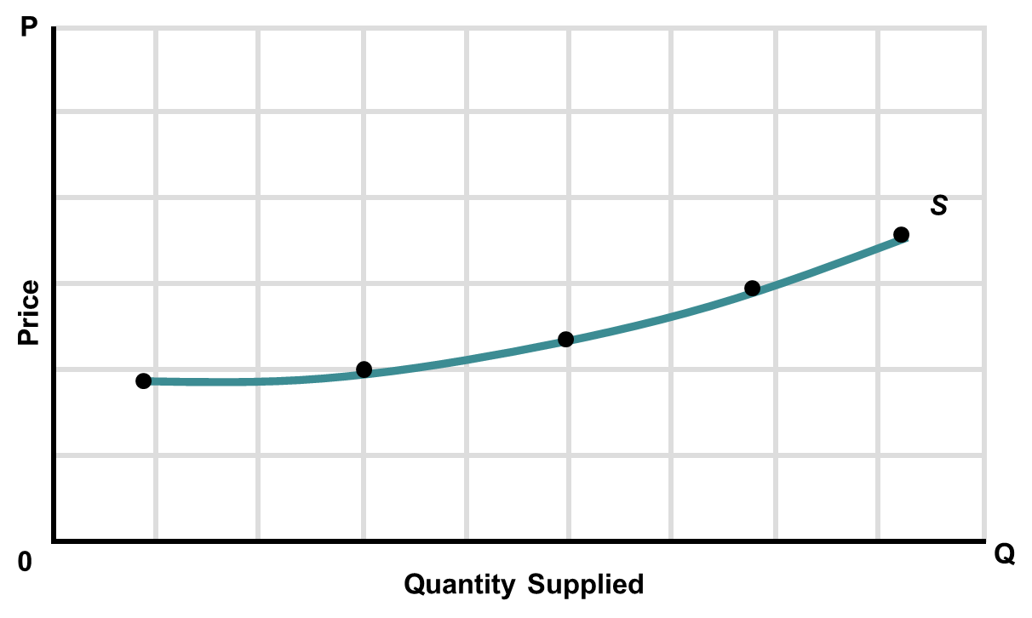
2. The consumption of poultry meat in Pakistan has increased 239% in the last 11 years from 322 million tons in 1999/2000 to 767 million tons in 2010/11. Over the years, many changes have been observed in the pattern of meat consumption in the country. The graph shows how the levels of preference of chicken and mutton have interchanged between the years 1995 and 2010.
Demand and supply of This Business

3. Equilibrium point of demand and supply can be graph easily where demand and supply intersect each other. As we know demand of Broilers is elastic:
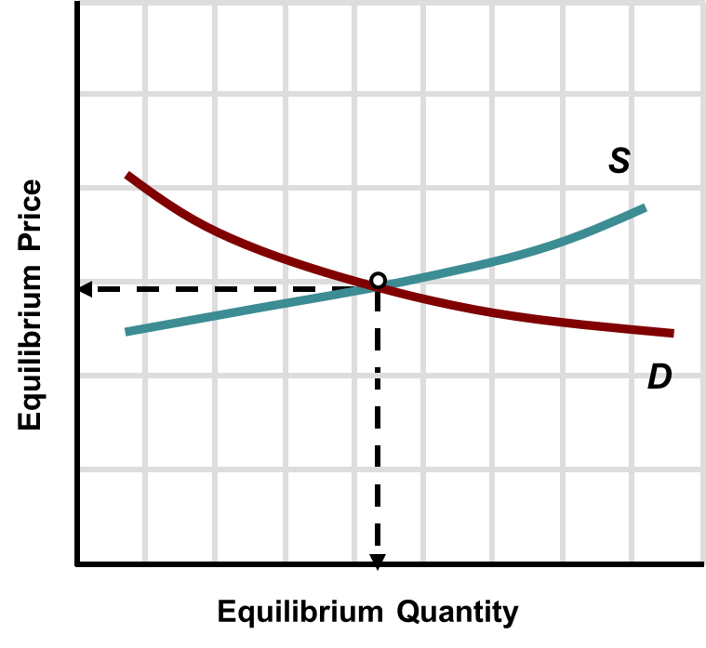
In Controlled Environment Farm, inputs including farm equipment’s (like drinkers, feed trays, brooders, and feeders and other items like feed, vaccines & medicines, rice-husk or saw-dust, water and electricity etc…) are required to achieve good production.
Farm Requirements & Management
Production Assumptions

Product | Avg. Live Weight (kg) | Price per kg
Chicken | 1.85 | Rs. 110

Number of Flocks per year | 6
Number of Birds per Flock | 35,000
Time required per Flock (Days) | 40
Lag time required per Flock (Days) | 15
Total Annual Production Capacity | 210,000
Shed Space Required per Bird (sq. ft.) | 0.65
Sale price growth rate (%) | 10
Production capacity utilization (%) | 100

Skilled workers are needed to look after the feeding, vaccination and cleaning operations at the farm. Following manpower is required for a farm of 35,000 birds:
Manpower Requirements
Description (HR  Requirements) | NO | Salary per  month | Salary per  Year
Supervisor | 1 | 10,000 | 120,000
House man | 2 | 11,000 | 132,000
Electrician | 1 | 7,500 | 90,000
Watch man | 2 | 11,000 | 132,000
Cleaner | 1 | 6,000 | 72,000
Total | 9 | 45,500 | 546,000

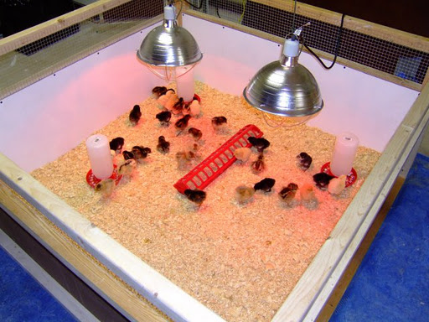
Various types of farm equipment’s are needed for feeding, drinking and handling the birds. List of farm equipment, which will be needed, is as under:
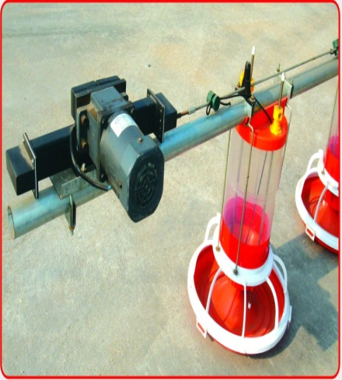
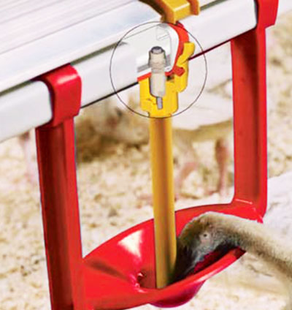
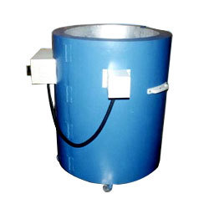

Farm Equipment’s & Machinery

Description | Amount Rs.
Main Feed Line System | 85,000
Feed Pan System | 524,170
Nipple Drinking System | 337,470
Ventilation System (Cone Fans) | 308,700
Minimum Ventilation Fan | 60,782
Pad Cooling System | 142,296
Minimum Ventilation System (Air Inlets with Accessories) | 185,304
Motor for Air Intel | 26,000
Controlling Equipment’s | 45,000
Heating System | 250,000
Total Cost of Machinery | 1,964,722

It is recommended that the proposed project should be started in a purchased land. These sheds are located along roadsides around cities and rural areas. Suburban and rural areas around the major cities of the country are the suitable areas for setting up a poultry farm. Setting up a farm at an isolated place will minimize the risk of disease.
Industry Profile
Land & Building
The farm should be located at a place where transportation of birds and feed can be handled easily. There should be following things are available at the farm site:
- Electricity connection
- Drinking quality water
Our control shed is located under all these characteristics. Our farm is at main road so we can easily transport from farm to markets and there is availability of Electricity connection as well as drinking quality water.

Land requirement for Control shed is given below:
Land | Per Acre Cost | Total Cost Rs.
1.5 Acre | 1,000,000 | 1,500,000

Total Building and infrastructure cost for Control shed is given below:

Land & Building
Description | Area (sq.ft.) | Cost (Rs. / sq.ft.) | Total (Rs.)
Shed Space (380ft X 61ft) | 23,180 | 570 | 13,212,600
Building for Resident & Office Purposes Ground Floor
Feed Store | 500
Toilet Block | 100
Admin Office | 100
Areas for Corridor | 150
Generator Set Room | 400
Store for Vaccine & Medicines & Misc. | 150
Changing / Store Room | 100
Rooms for Staff | 400
Kitchen | 80
Total Area | 1980 | 750 | 14,85,000
Boundary wall 7 feet height |  |  | 500,000
Total Building & Infrastructure Cost |  |  | 14,697,600

Costs for a startup business can be divided up into two major categories:
Various Types of costs
- Administrative Costs:
Various types of things you need to have on a daily basis to operate a business:
Administration expense | 546,000
Administration benefits expense | 16,380
Travelling expense | 27,300
Communication expense | 16,380
Office expense (stationary etc…) | 16,380
Professional fees (legal, audit etc.) | 20,726
Depreciation expense | 1,029,639
Amortization of pre-operating costs | 16,000
Subtotal | 1,688,805
- Cost of Sale:
Various types of things you need to have for sale your product:
Cost of DOC | 12,600,000
Cost of Feed | 18,000,000
Operations costs (direct labor) | 300,000
Vaccination, Medication & Disinfection | 1,500,000
Direct Electricity | 2,000,000
Diesel for Generator & Heater | 1,500,000
Litter & Spray Cost | 240,000
Total cost of sales | 36,140,000

Costs when business will going on can be divided up into two major categories

- Fixed Cost:
In economics, fixed costs are business expenses that are not dependent on the level of goods or services produced by the business.
Basically, almost all admin & general expenses are our fixed costs because salaries, office expenses etc… will be occur while production is being or not.
Various Types of costs

- Variable Cost:
Variable costs are expenses that change in proportion to the activity of a business.
Basically, almost all costs of sales are our variable expenses.

Capital Investment | Rs.
Land | 1,500,000
Building/Infrastructure | 14,697,600
Machinery & Equipment | 2,882,591
Furniture & Fixture | 35,000
Office equipment | 30,000
Pre-Operating Costs | 80,000
Total Capital Costs | 19,225,191

Working Capital | Rs.
Raw material inventory | 5,200,000
Cash | 500,000
Total Working Capital | 5,700,000

Total Investment | 24,925,191
Total Project Cost
A cost benefit analysis is done to determine how well, or how poorly, a planned action will turn out. Although a cost benefit analysis can be used for almost anything, it is most commonly done on financial questions. Cost benefit analysis relies on the addition of positive factors and the subtraction of negative ones to determine a net result.
Cost-Benefit Analysis
Total cost on this Project*= 39,522,341
Total Revenue earn from this business**= 41,452,950
So,
Total Profit earn from this business per year = 1,930,609
Cost benefit analysis clearly shows that the starting of this business is justified. And the business will save almost Rs/= 190,000 a year.

* Total cost includes Cost of Sales, General Administration & Selling costs, Interest and taxes.
** Total Revenue includes Revenue from sale of birds.

Total revenue
Revenue from sale of birds  Income Statement Analysis | 41,452,950
Sale of Feed Bags | -
Sale of Rice Husk | -
Total Revenue | 41,452,950

Cost of Sales
Cost of DOC | 12,600,000
Cost of Feed | 18,000,000
Operations costs (direct labor) | 300,000
Vaccination, Medication & Disinfection | 1,500,000
Direct Electricity | 2,000,000
Diesel for Generator & Heater | 1,500,000
Litter & Spray Cost | 240,000
Total cost of sales | 36,140,000

Gross Profit: Total revenue – Total Cost of Sales
Gross Profit | 5,312,950

General Administration & selling Expenses
Income Statement Analysis
Administration expense | 546,000
Administration benefits expense | 16,380
Travelling expense | 27,300
Communication expense | 16,380
Office expense (stationary etc…) | 16,380
Professional fees (legal, audit etc.) | 20,726
Depreciation expense | 1,029,639
Amortization of pre-operating costs | 16,000
Subtotal | 1,688,805
Operating Income
Operating Income | 36,24,145
Earnings before Interest & Tax
Earnings Before Interest & Tax | 36,24,145
Interest expense on Long term debt
Interest expense on Long term debt | 10,50,000
Tax
Tax | 643,536
NET PROFIT: Operating Income – Interest & Tax
Net Profit after Tax | 19,30,609
The statement of Income clearly show that after invest in this business, we can earn 160,800 monthly and almost 1.9 Million yearly. As mention above:
Profit & loss Analysis
Total cost on this Project= 39,522,341
Total Revenue earn from this business= 41,452,950
So,
Total Profit earn from this business per year = 1,930,609
Profit that estimate for next 10 years is plot below:

Thank You

